Arweinydd y Cyngor/Leader of the Council
Y Cynghorydd/Councillor Mark Pritchard

Neuadd y Dref, Wrecsam. LL11 1AY
Guildhall, Wrexham. LL11 1AY
Ffôn/Tel: 01978 292581
www.wrecsam.gov.uk www.wrexham.gov.uk

VIA EMAIL  Lesley Griffiths, MS  Constituency Office  Vernon House  41 Rhosddu Road  Wrexham  LL11 2NS | Eich Cyf/Your Ref
 | Ein Cyf/Our Ref | MP/AMP
 | Dyddiad/Date | 13 January, 2021
 | Gofynner am/Ask for | Cllr Mark Pritchard
 | Rhif Union/Direct Dial  E-bost/E-mail | 01978 292581  leader@wrexham.gov.uk
Dear Lesley

Rollout of Vaccine Programme in Wrexham and North Wales

As you will be aware, communities in North Wales specifically in Wrexham are now acutely interested in the progress of vaccinating priority groups as soon as is possible.

Whilst we are fully aware that the challenge this poses is significant, I would wish reassurance and clarity on a number of issues which are of interest to our constituents in Wrexham.

- Which GP Surgeries have been vaccinating in Wrexham to date and a clarity as to why these GPs were selected first.

- We understand that General Practitioners have been approached to support this work. When therefore will vaccinations be available within all other local areas and GPs in Wrexham?

- Can we have a list of GP surgeries that have signed up to the vaccination distribution and are going to be used and those that are not. If we have some local GP’s who have chosen not to sign up, can we have confirmation of how their patients will receive the vaccine.

- Further detail regarding the opening of local vaccination centres. We understand now given the support expressed by GP practices that opening may be delayed but a clear statement regarding when and if they will be opened would be valued.

- Confirmation that North Wales and specifically Wrexham are having equal access to vaccinations. There are early indications that levels of vaccinations in North Wales fall below those in some other areas of Wales and naturally we would wish to understand the reasons for this and how within a short period of time this will be levelled out.

- A comprehensive plan now (even if it is provisional and subject to change later) which covers the points above and the use of mass vaccination centres, local centres, GPs pharmacies, and opticians in the distribution of the vaccine.

- Confirmation that there are sufficient resources behind the Plan (PHW, BCUHB, LAs, Police and Army if necessary). We know this is a massive undertaking and needs lots of resources behind it.

- Leadership behind the plan which provides sufficient seniority to ensure a co-ordinated approach across partners.

- A shared approach to communications both at a strategic and local level. It is valued that messages are being shared but we feel that this could be greatly strengthened to ensure a consistent approach across all of us.

- Transparent data on how many vaccinations have been delivered to date, where, and to which populations and the same information moving forwards.

Please be reassured that we are supportive of collective work across our organisations to drive forward the vaccination programme but understand that responses to these areas are essential so that we can reassure communities that there is a robust plan for vaccinating people in North Wales and specifically in Wrexham, which does not disadvantage anyone locally. Your urgent attention to this would be welcome and I have also written in similar terms to Ken.

Yours sincerely

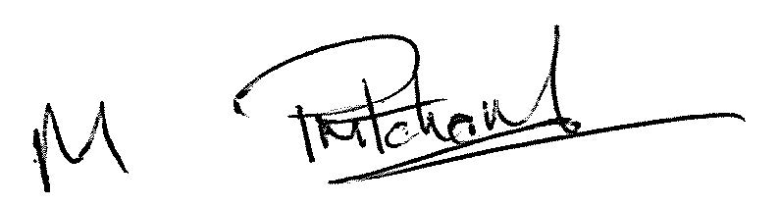

Councillor Mark Pritchard
Leader

