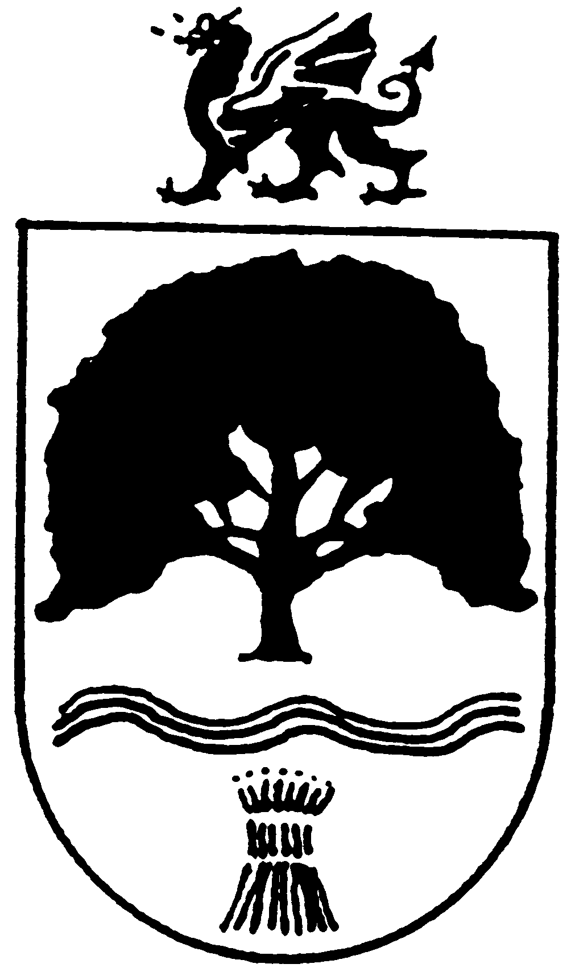
OVERTON
COMMUNITY COUNCIL
13th January 2021

The FULL COUNCIL MEETING of OVERTON COMMUNITY COUNCIL
Is due to be held remotely (The Local Authorities (Coronavirus) (Meetings) (Wales) Regulation 2020), on Tuesday 9th February 2021 at 6.50pm – Council meeting commences at 7.00pm. Members of the public and press are welcome to attend the meeting and may speak on any issues between 6.50pm and 7.00pm – Please email the Clerk for log-in details.

