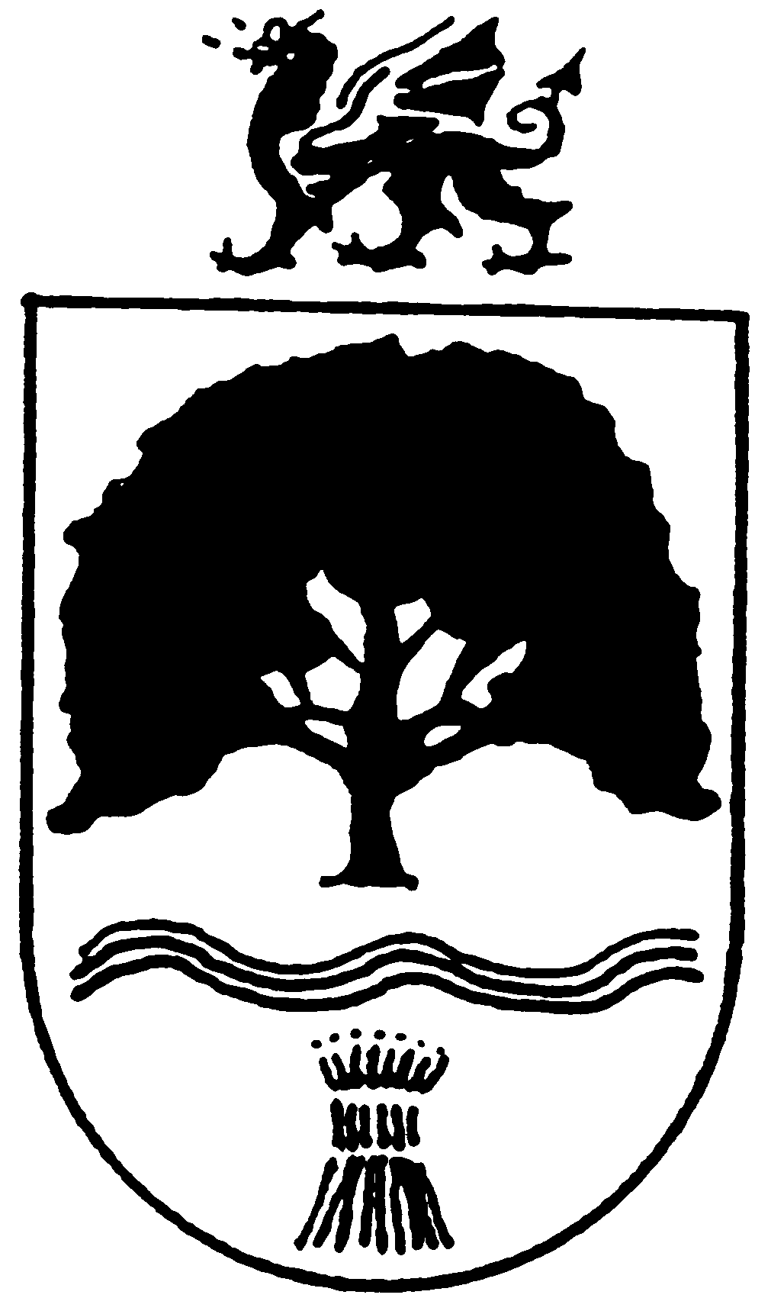
OVERTON
COMMUNITY COUNCIL
27th October 2020

The FULL COUNCIL MEETING of OVERTON COMMUNITY COUNCIL
Will meet on Tuesday 10th November 2020 6.50pm – Council meeting commences at 7.00pm, this meeting will be held remotely
The public and press are cordially invited to be present

Please email the Clerk for log-in details – clerk@overton-on-dee.co.uk

The Local Authorities (Coronavirus) (Meetings) (Wales) Regulation 2020.

