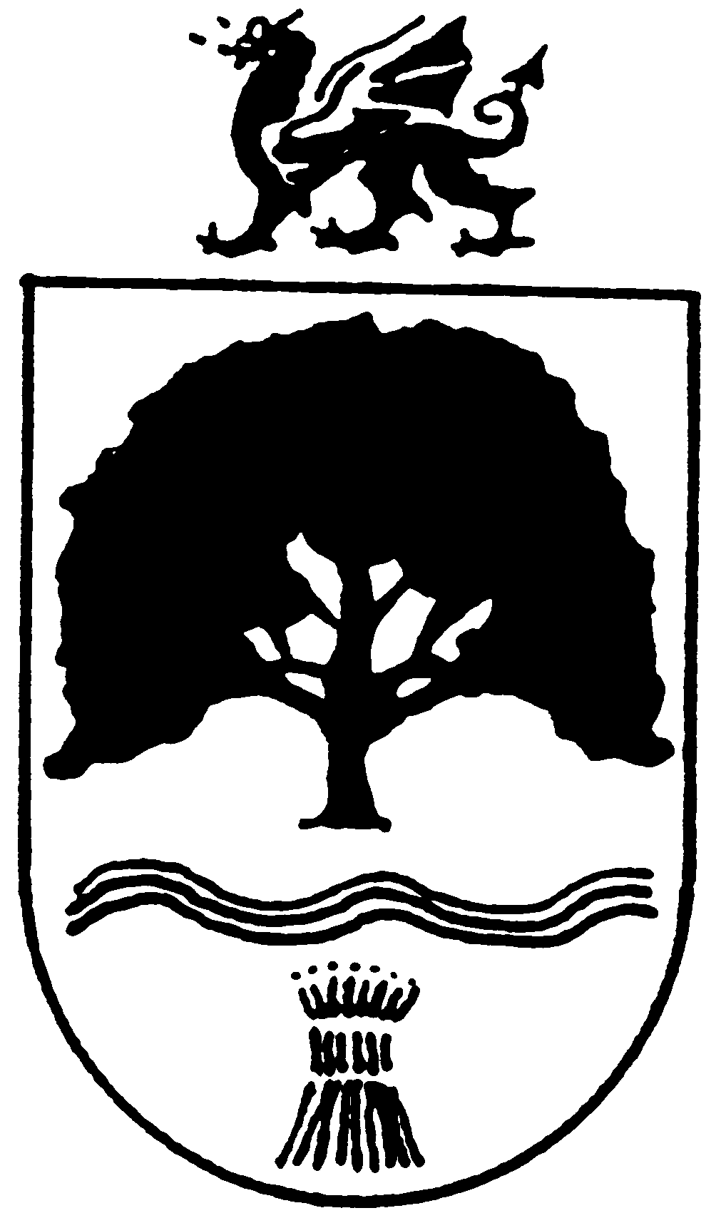
OVERTON
COMMUNITY COUNCIL
14th October 2019

The FULL COUNCIL MEETING of OVERTON COMMUNITY COUNCIL
is
at the Parish Rooms, Overton,
on Tuesday 12th November 2019 at 6.50pm

The public and press are cordially invited to be present

