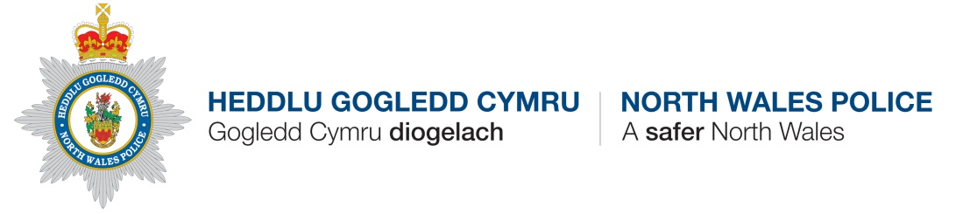
Police Update – WRW02 Areas including Overton, Penley, Hanmer, Bettisfield and other surrounding areas.

Contact Details
PCSO Catherine Griffiths Hughes 2912
Overton Station
Station Road
OVERTON
LL13 0EF
Catherine.Griffiths-hughes2@nthwales.pnn.police 07854329534

HGC Wrexham Wledig/NWP Wrexham Rural
Incident update – 01/10/2019 – 31/10/2019

Anti-Social Behaviour Issues/Trends:

1 x Parking dispute – Overton.

Crime Issues / Trends:

Malicious Communication – Overton – Person receiving unwanted messages on Facebook from a known person – Detected

Theft – Penley School – Unknown person has stolen IP’s watch – Undetected

Burglary Dwelling – Penley – Unknown offenders have gained entry into IP’s house and stolen their car and other items – Enquiries ongoing

Common Assault – Hanmer – Known offender has assaulted IP – Enquiries ongoing

Other News/PCSO activities:
Please contact me via the email address given for any specific issues that need addressing in the area.
Unfortunately PCSO Lydia Edwards is no longer covering the area
The Halloween Disco that was held on the 30th October at Overton Village hall was a massive success with over a 100 children attending.

There is currently an operation ongoing tackling thefts and burglaries in the area whereby officers are patrolling and targeting areas overnight.

