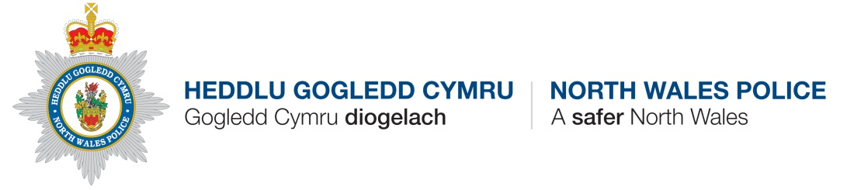
Police Update – WRW02 Areas including Overton, Penley, Hanmer, Bettisfield and other surrounding areas.

Contact Details
PCSO Catherine Griffiths Hughes 2912
Overton Station
Station Road
OVERTON
LL13 0EF

Catherine.Griffiths-hughes2@nthwales.pnn.police 07854329534

HGC Wrexham Wledig/NWP Wrexham Rural
Incident update – 01/11/2019 – 30/11/2019

Anti-Social Behaviour Issues/Trends:

- Threats made over Facebook – Hanmer

- ASB on Facebook - Penley

Crime Issues / Trends:

Burglary Dwelling – Horsemans Green – Unknown offenders have gained entry into IP’s house and stolen a number of items– Enquiries ongoing
Other News/PCSO activities:
Please contact me via the email address given for any specific issues that need addressing in the area.

Speed Checks have been conducted in Hanmer. 23 vehicles were checked, 9 were going over 20mph fastest being 25mph

Speed checks conducted in the area of Overton with local officers and Councillors.

There is currently an operation ongoing tackling thefts and burglaries in the area whereby officers are patrolling and targeting areas overnight.

