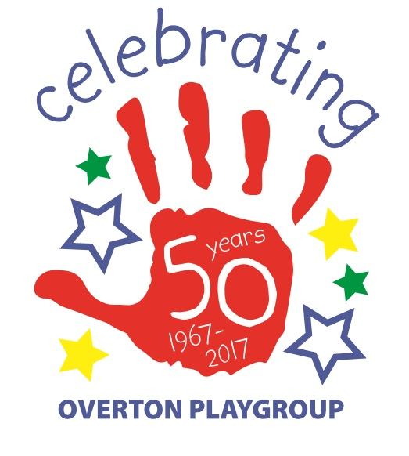
Overton Playcentre and St Mary’s Church Christmas Tree Festival
Saturday 7th and Sunday 8th December

Do you like a challenge? This year The Christmas Tree Festival has an Environmental Twist! As everyone is aware of Climate change and the need to reuse and recycle we would like to challenge YOU to create your own tree as well as dress it! The competition will include the most inventive tree as well as the best dressed tree and will be judged in different categories with an overall best in show tree! There may be a few ready made trees to sponsor but we are hoping you will take up the challenge!
It will be open to the public from 12-4pm both days, there will be a raffle and Festive Afternoon Teas will be served all weekend. There will be a small number of craft stalls on the Saturday afternoon too!
We hope that this will be a wonderful special Christmas village event and lots of fun too!
We are inviting you along with local businesses, charity groups and families to make and decorate a tree! We are only asking for a booking fee of £3 this year if you are making your own tree!!

On Saturday 30th November 10am-3pm we are hosting a Crafternoon workshop, in aid of Mind, to make your own tree if you would like help to create it with us!. There will be pallets, cardboard, newspaper hopefully available to create your design. Please bring items too. Donations for teas coffees, mulled wine as well as cakes and mince pies will be given to MIND, for better mental health.

Alternatively bring your already created tree to the church on Friday 6th December between 2pm -7pm pre–decorated or to decorate in church! Mulled wine and mince pies will be available for a donation!
Saturday Stalls will need to be set up by 10am (as the Playcentre Christmas Play will be starting around 1030am) and finish at 4pm.
After the festival the trees will remain in St Mary’s Church until the 21st of December when they will be available to take away between 2-4pm. .
We really hope that you will want to be involved! Please find below a form to fill in and return with your payment to us at Overton Playcentre.
Overton Playcentre and St Mary’s Church Presents
An Environmental Christmas Tree Festival
at St Marys Church 7th and 8th December
Booking form
I/we would like to make and decorate a tree . I/We agree to bring and decorate our tree between 2-7pm on Friday 6th at St Mary’s Church. We agree to collect our decorated trees on Saturday 21st between 2-4pm or have made other arrangements by prior agreement with Overton Playcentre if we need to remove it earlier.
Name
and Contact details
Created decorated Tree £3.00 booking fee
Saturday Stall @ £10
Signed and Date
Total payment enclosed
