CIDERFEST’20

SATURDAY 29th FEBRUARY
at
THE SCOUT HUT
From 4.30pm to 7.30pm

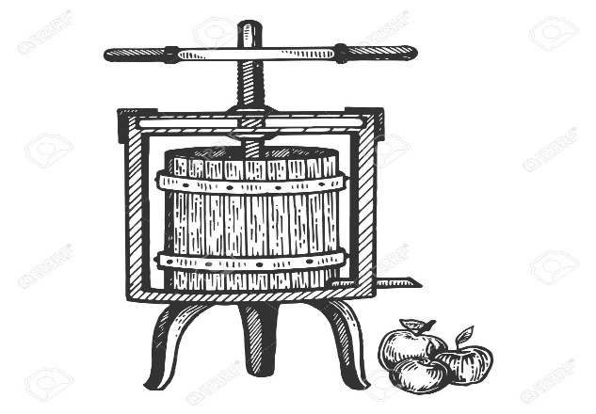
YOU ARE INVITED TO JOIN US TO CELEBRATE THE FIRST
VINTAGE OVERTON CIDER MADE FROM LOCAL APPLES GATHERED AND PRESSED IN OCTOBER 2019

Entry is free, so don’t leave it too late to pop in as -
WHEN IT’S GONE, IT’S GONE!

Tea, coffee, homemade soup and other light refreshments also available

A variety of Woodfired Pizzas may be ordered from the
‘Dough Nation Station’
These must be ordered in advance
via the Growers’ Facebook page, by phone on 01978 710328 or e-mail cathroberts100@aol.com

