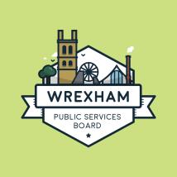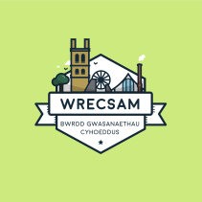
WREXHAM PUBLIC SERVICES BOARD
c/o 3rd Floor
Guildhall
Wrexham
LL11 1AR

20th October 2016

Dear Wrexham Town & Community Council Forum Member

Wrexham Public Services Board

I am contacting you in my role as support to the Wrexham Public Services Board (PSB) for three reasons.

1 As you are probably aware the PSB are currently working towards meeting the requirements of the Well-Being of Future Generation (Wales) Act by undertaking a well-being assessment for the local area, and Community Councils are one of our key stakeholders.

You may have attended one of our consultation events that we have been holding or you may have filled in our on line consultation:

http://www.yourvoicewrexham.net/KMS/news.aspx

If you haven’t as yet taken part with our consultation can I encourage you to do so, and encourage residents of your local area too. The closing date for the consultation “The Wrexham We Want” is 24th October 2016.

2 The Well Being of Future Generations (Wales) Act has also produced some statutory guidance for Community Councils “SPSF 4 – Guidance for community councils on taking reasonable steps to contribute to the local well-being plan”.

http://gov.wales/topics/people-and-communities/people/future-generations-act/statutory-guidance/?lang=en

I am proposing to come to the next Town & Community Council Forum on Thursday 8th December, 2016 to give you an overview of the work the PSB has been undertaking and to discuss any queries you may have with the SPSF4 Guidance.

3 At a “Customers, Performance, Resources and Governance Scrutiny Committee” held at the Council earlier this year it was suggested that Community Councils are represented on the Wrexham PSB. Again I will raise this at the meeting on the 8th December to gain your views on this suggestion, and to find out how you would like to take this forward. The PSB have indicated that they are open to suggestions from you.

In the meantime if you have any queries please do get in touch, either at helen.odunaiya@wrexham.gov.uk , 01978 2912273 or the address above. Otherwise I will be attending your Town & Community Council Forum on 8th December 2016.

Yours sincerely

Helen Odunaiya
Partnerships and Equalities Lead (PIPS)
Wrexham County Borough Council

